 

 

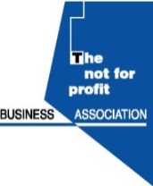 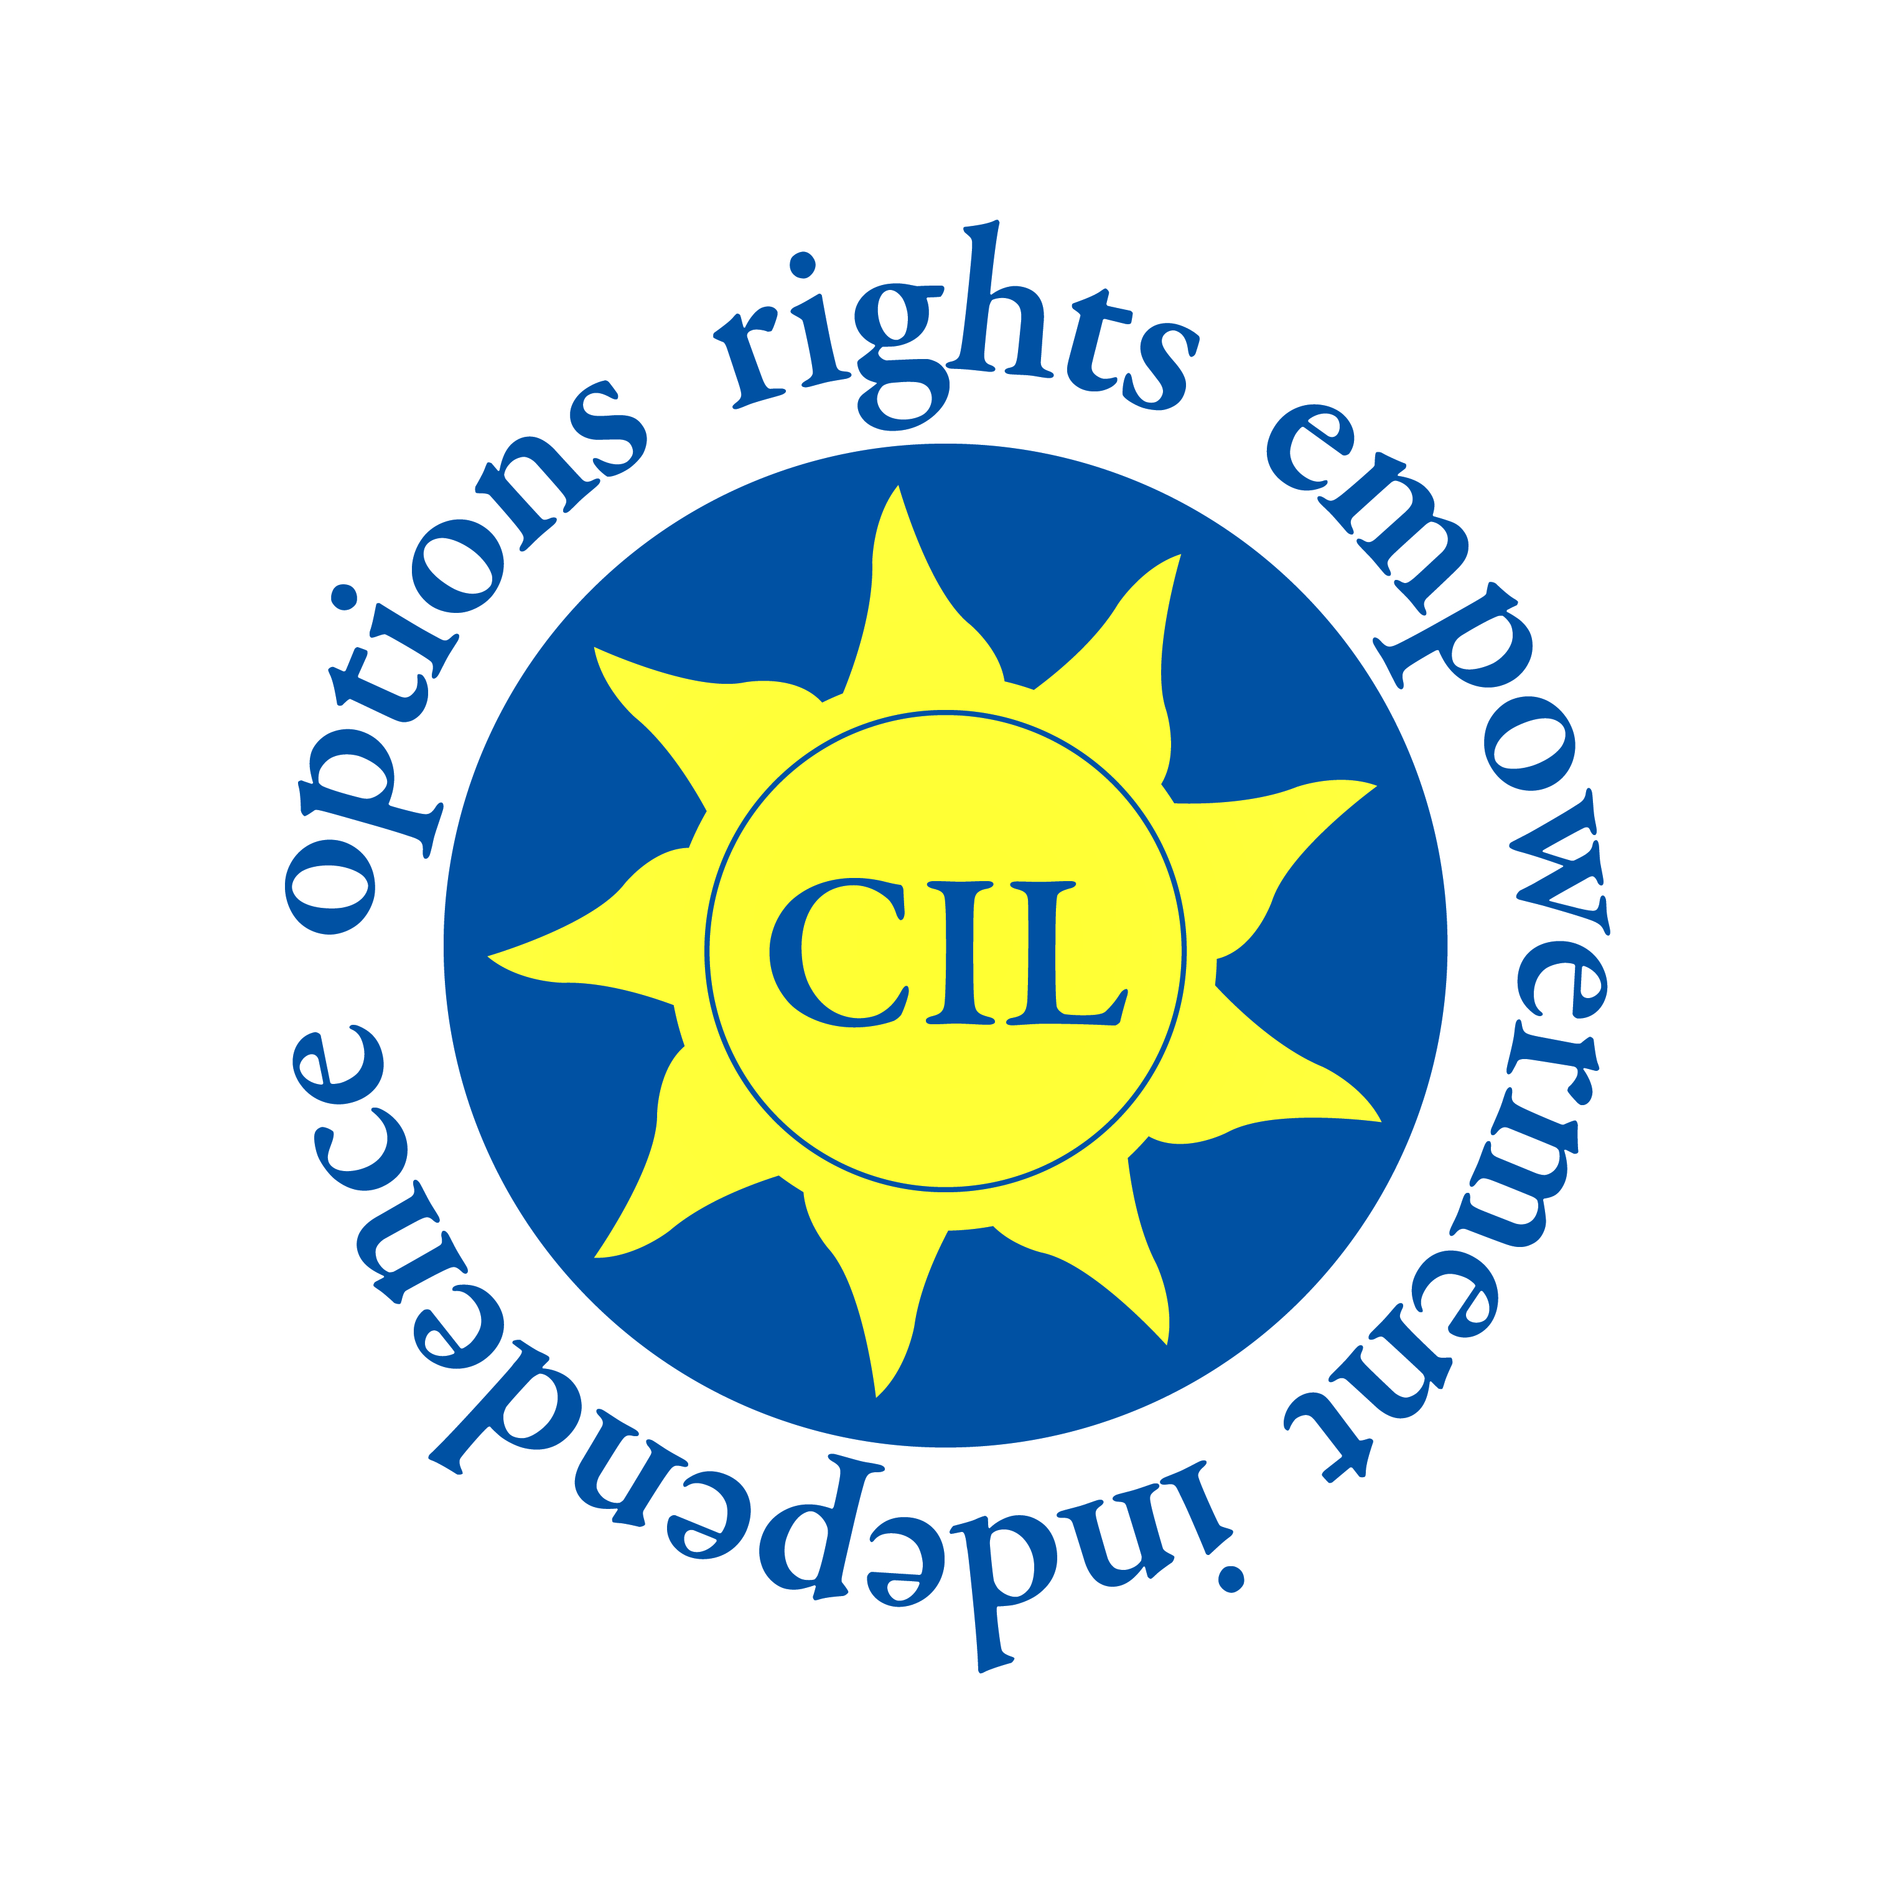 

**Budget 2015 – Don’t Leave Us Behind - Time for Government to demonstrate its commitment to People with Disabilities and those with Mental Health Needs.**

**Wednesday 1st October 2014** – We, the under-signed national voluntary disability organisations[1], representing the diversity of people with disabilities, including mental health, make this joint statement to Government regarding Budget 2015.

At each consecutive budget since 2008, this government have undermined their own promise to “forge a new Ireland that is built on fairness and equal citizenship” [2]. The range of health and social supports available to people to maintain their independence, dignity and well-being has been depleted to such an extent that the entire social infrastructure is in danger of collapse. In light of this governments track record, and in particular their recent decisions to cut the SSNO funding to 26 disability organisations and the withdrawal of the Discretionary Medical Cards, we say to this Government on behalf of people with disabilities, mental ill-health and families “Don’t Leave us Behind” and improve these vital services and supports.

Budget 2015 will provide us with a clear expression of government priorities. To-date, we have seen that the economic has taken precedence over the social. Endless evidence is there to show this and yet the government still speaks and aspires to be ‘socially inclusive’. The number of draconian measures that have devastated essential secondary benefits and community supports for people to live a decent standard of living with access to services is unacceptable. Families too have been inexcusably impacted by cutbacks and pressure to provide more and more services under the disguise of ‘austerity’. We are clearly saying ‘this has to stop’.

We need to strategically plan for social inclusion and this planning should be demonstrated in Budget 2015. Furthermore, innovative, quality services and supports should not be targeted in this budget. Human rights and social inclusion should not become the collateral damage of this recession.

We are seeking a rebalancing of the recovery programme and the protection of, and investment in, people with disabilities and conditions which are disabling. Budget 2015 must be driven not only by fiscal considerations but by the adjacent pursuit of sustainable social outcomes.

1. **Ensure funding for services and supports for people with disabilities.** Reducing the independence of people with disabilities drastically reduces their quality of life resulting in increased costs to the state. Ensuring the accessibility of all public and community based services and empowering people with disabilities to become more independent positively impacts on wellbeing and reduces reliance on state run services.
2. **Halt reductions to** **the basic standard of living of people with disabilities requiring welfare support.** This means recognising the extra costs that people with disabilities incur and noting their disproportionate likelihood of experiencing poverty.
3. **Appoint a Minister to Cabinet with overall responsibility to drive and coordinate** ‘disability inclusion’ across government departments and state agencies. Disability is a societal issue, and not a sectoral one, that stretches across the life cycle, affecting people of all ages and their families directly and indirectly. Reform is required to change how Government Departments operate, to achieve mainstreaming and person centred outcomes, and to ensure that these efforts are in line with the Government's implementation plan for the National Disability Strategy. These actions, to ensure the social, economic and cultural rights of people with disabilities need to be driven from Cabinet level.
4. **Ensure the ambition, commitment and cultural shift required in reforming the public service exists to drive forward the delivery of the commitments in the National Disability Strategy.** Robust implementation of the NDS will be required if Ireland is to fulfill its obligations under the United Nations Convention on the Rights of Persons with Disabilities, which is yet to be ratified.

**Signed:**

**Disability Federation of Ireland Care Alliance Ireland**

**Neurological Alliance of Ireland Center for Independent Living**

**Mental Health Reform National Federation of Voluntary Bodies**

**Not for Profit Business Association**

1. Care Alliance Ireland, Centre for Independent Living, Disability Federation of Ireland, Genetic and Rare Disorders Organisations, Mental Health Reform, Neurological Alliance of Ireland, Not For Profit Business Association, National Federation of Voluntary Bodies.
2. Programme for Government.2011:2